Tab 1
Pinkvilla - CMS Architecture (Secure, Scalable)
We use a heavily customized WordPress CMS hosted privately behind VPN, with RDS as the source of truth, Redis for performance, and Solr for fast search—secured with RBAC and 2FA.

Technology Stack
Layer | Technology | Instance Type
CMS Application | Customized WordPress (EC2) | r6g.large
Database | Amazon RDS (Writer + Reader) | db.r5.large
Cache | Amazon ElastiCache (Redis) | cache.r6g.large
Search | Apache Solr | r6gd.large
Network | VPC + Private Subnets | —
Access | VPN Gateway + HTTPS | —

High-Level Architecture Flow

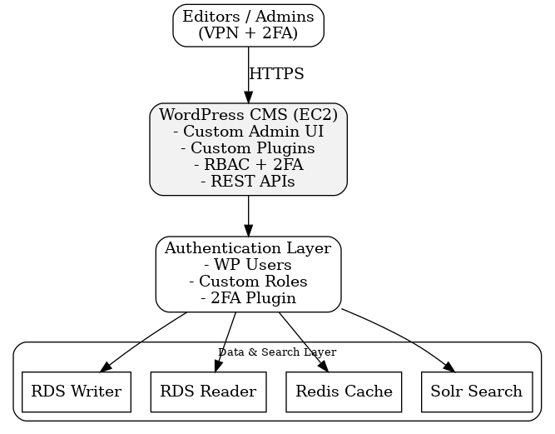

Architectural Diagram
